**Code**

**Main.java**

**package** application;

**import** javafx.application.Application;

**import** javafx.fxml.FXMLLoader;

**import** javafx.stage.Stage;

**import** javafx.scene.Parent;

**import** javafx.scene.Scene;

**import** javafx.scene.layout.BorderPane;

**public** **class** Main **extends** Application {

@Override

**public** **void** start(Stage primaryStage) {

**try** {

Parent root = FXMLLoader.*load*(getClass().getResource("Main.fxml"));

// BorderPane root = new BorderPane();

Scene scene = **new** Scene(root);

scene.getStylesheets().add(getClass().getResource("application.css").toExternalForm());

primaryStage.setScene(scene);

primaryStage.setTitle("Assignment2-Sultan-1080082");

primaryStage.show();

} **catch**(Exception e) {

e.printStackTrace();

}

}

**public** **static** **void** main(String[] args) {

*launch*(args);

}

}

**Main.fxml**

<?xml version=*"1.0"* encoding=*"UTF-8"*?>

<?import javafx.scene.control.Button?>

<?import javafx.scene.control.Label?>

<?import javafx.scene.control.TextField?>

<?import javafx.scene.layout.AnchorPane?>

<AnchorPane prefHeight=*"157.0"* prefWidth=*"579.0"* xmlns=*"http://javafx.com/javafx/18"* xmlns:fx=*"http://javafx.com/fxml/1"* fx:controller=*"application.controller"*>

<children>

<AnchorPane layoutY=*"-8.0"* prefHeight=*"202.0"* prefWidth=*"579.0"*>

<children>

<Button layoutX=*"416.0"* layoutY=*"136.0"* mnemonicParsing=*"false"* onAction=*"#sign"* text=*"Signature"* />

<Button layoutX=*"260.0"* layoutY=*"136.0"* mnemonicParsing=*"false"* onAction=*"#mult"* text=*"Mutiply"* />

<Button layoutX=*"340.0"* layoutY=*"136.0"* mnemonicParsing=*"false"* onAction=*"#div"* text=*"Divide"* />

<Button layoutX=*"83.0"* layoutY=*"136.0"* mnemonicParsing=*"false"* onAction=*"#add"* text=*"Add"* />

<Button layoutX=*"160.0"* layoutY=*"136.0"* mnemonicParsing=*"false"* onAction=*"#sub"* text=*"Substract"* />

<Label layoutX=*"14.0"* layoutY=*"29.0"* text=*"Number 1:"* />

<Label layoutX=*"165.0"* layoutY=*"29.0"* text=*"Number 2:"* />

<Label layoutX=*"340.0"* layoutY=*"29.0"* text=*"Result:"* />

<Label fx:id=*"Xiaojie_Zhu"* layoutX=*"488.0"* layoutY=*"29.0"* text=*"Xiaojie Zhu"* />

<TextField fx:id=*"number1TextFiled"* layoutX=*"81.0"* layoutY=*"25.0"* prefHeight=*"18.0"* prefWidth=*"58.0"* text=*"0"* />

<TextField fx:id=*"resultTextFiled"* editable=*"false"* layoutX=*"385.0"* layoutY=*"25.0"* prefHeight=*"26.0"* prefWidth=*"86.0"* text=*"0"* />

<TextField fx:id=*"number2TextFiled"* layoutX=*"230.0"* layoutY=*"24.0"* prefHeight=*"26.0"* prefWidth=*"85.0"* text=*"0"* />

</children>

</AnchorPane>

</children>

</AnchorPane>

**controller.java**

**package** application;

**import** javafx.fxml.FXML;

**import** javafx.scene.control.Label;

**import** javafx.scene.control.TextField;

**import** javafx.scene.paint.Color;

**public** **class** controller {

**float** num1,num2,res;

@FXML

TextField number1TextFiled;

@FXML

TextField number2TextFiled;

@FXML

**private** TextField resultTextFiled;

@FXML

Label Xiaojie_Zhu;

**public** **void** add() {

**try** {

num1=Integer.*parseInt*(number1TextFiled.getText());

num2=Integer.*parseInt*(number2TextFiled.getText());

res=num1+num2;

System.***out***.print(res);

resultTextFiled.setText(String.*valueOf*(res));

}

**catch**(Exception e) {

System.***out***.println(e);

}

}

**public** **void** sub() {

**try** {

num1=Integer.*parseInt*(number1TextFiled.getText());

num2=Integer.*parseInt*(number2TextFiled.getText());

res=num1-num2;

System.***out***.print(res);

resultTextFiled.setText(String.*valueOf*(res));

}

**catch**(Exception e) {

System.***out***.println(e);

}

}

**public** **void** mult() {

**try** {

num1=Integer.*parseInt*(number1TextFiled.getText());

num2=Integer.*parseInt*(number2TextFiled.getText());

res=num1*num2;

System.***out***.print(res);

resultTextFiled.setText(String.*valueOf*(res));

}

**catch**(Exception e) {

System.***out***.println(e);

}

}

**public** **void** div() {

**try** {

num1=Integer.*parseInt*(number1TextFiled.getText());

num2=Integer.*parseInt*(number2TextFiled.getText());

res=num1/num2;

System.***out***.print(res);

resultTextFiled.setText(String.*valueOf*(res));

}

**catch**(Exception e) {

System.***out***.println(e);

}

}

**public** **void** sign() {

Xiaojie_Zhu.setTextFill(Color.*web*("red"));

Xiaojie_Zhu.setText("Sultan");

}

}

**Output**

**Without Any Input**

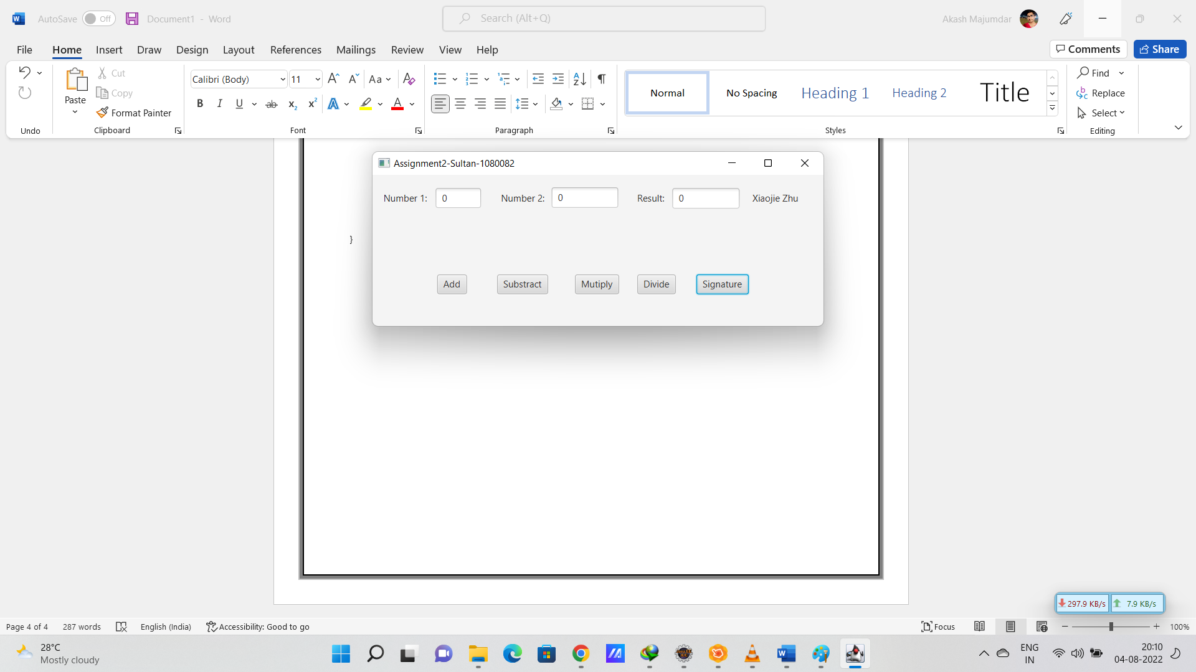

**After Addition**

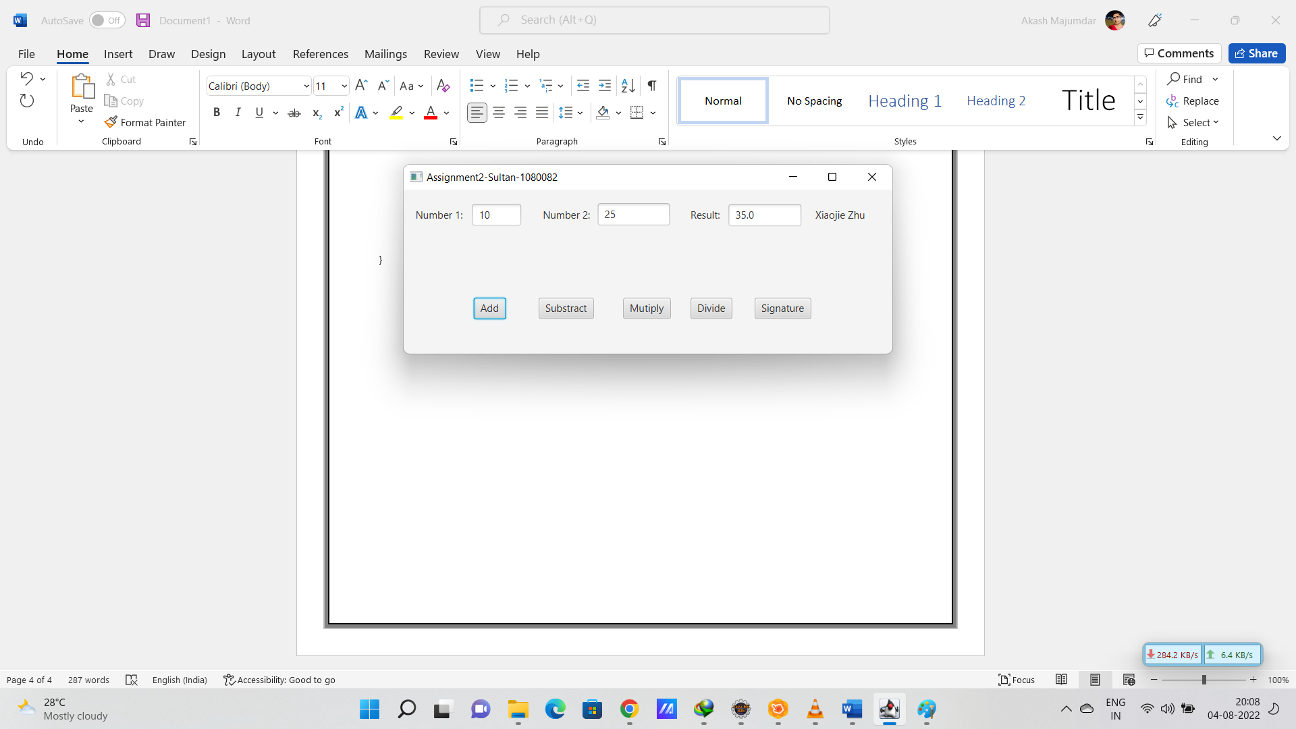

**After Substraction**

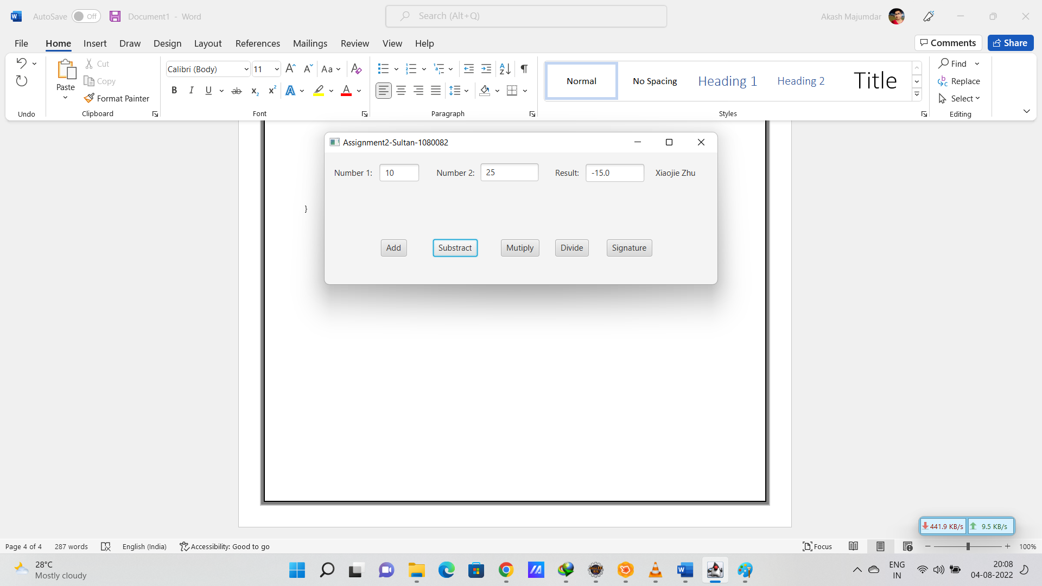

**After Multiplication**

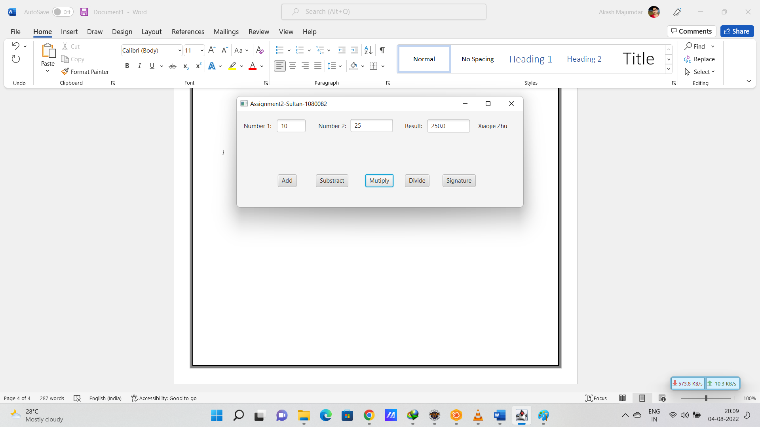

**After Division**

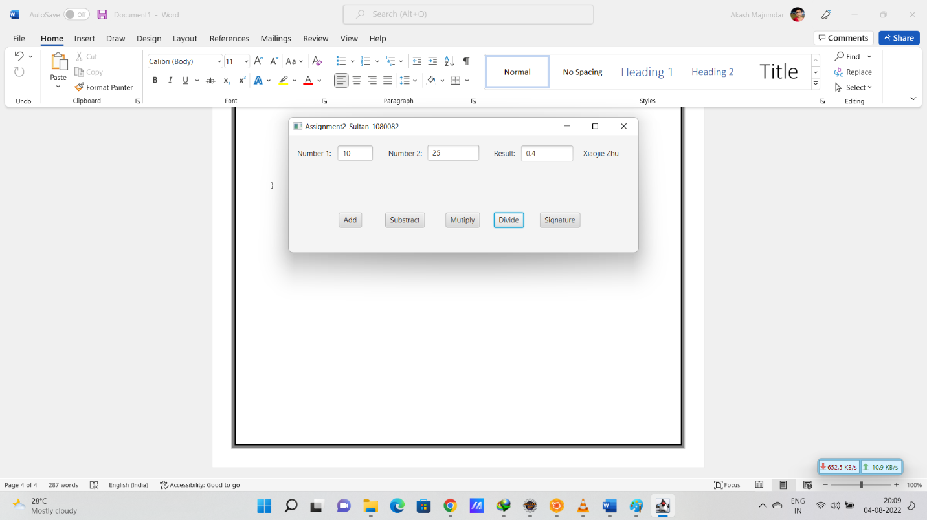

**After Signature**

